ACADEMY TERRACE HOMEOWNERS ASSOCIATION 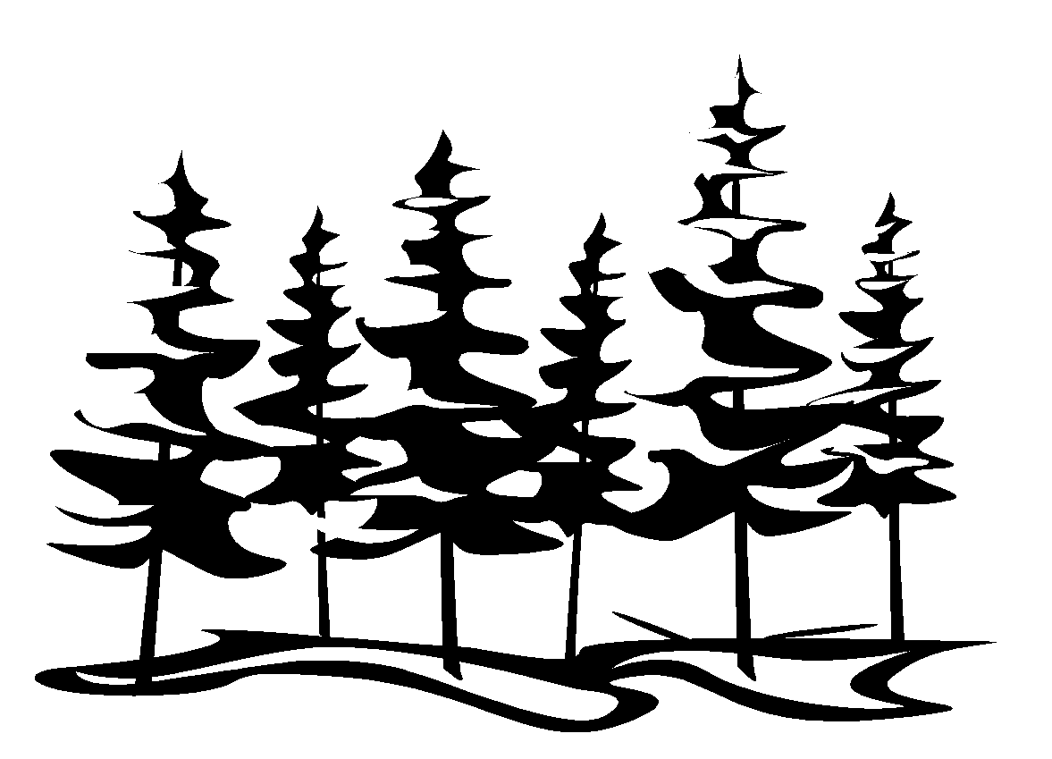

**2022 FALL NEWSLETTER**

**P.O. Box 64121, University Place, WA 98464**

**Website: AcademyTerracehoa.com**



**Dates to remember Board Members NEEDED**



*GREAT NEIGHBORS MAKE A GREAT COMMUNITY!!!!!!*



September 1, 2022