ACADEMY TERRACE HOMEOWNERS ASSOCIATION

j0155671

**2020 SPRING NEWSLETTER**

**P.O. Box 64121, University Place, WA 98464**

**Website: AcademyTerraceHOA.com**

# Your Volunteer Board of Directors for 2019-2020

**Rob Ross**, President **Sharon Predoehl**, Secretary **Annie Lovell**, Board Member

**Monica Hauss**, Vice President **Tom Williams**, Board Member **Susan Peterson**, Board Member

**Roberta Runion,** Treasurer **Rosemarie Routson**, Board Member

**Spring Egg Hunt Decision**

The Board of Directors made the difficult decision to cancel the Annual Spring Egg Hunt in light of the COVID-19 pandemic. Keeping social distance and sheltering in place is absolutely critical in order to slow the progression of this virus. We hope you are all doing well and remember to check on your neighbors who may need assistance.

.

* You may contact the board via the website “contact us” tool for follow-up to this newsletter AcademyTerraceHOA.com/contact-us

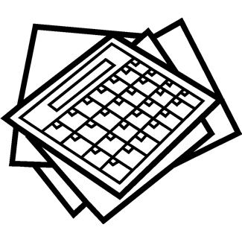

**Dates to remember Neighborhood Information**



**Add these to your calendar:**

**ATHOA Board Meeting -** First Thursdays of the month at Rob Ross’s home, 6:30 pm

**ATHOA Spring Egg Hunt—**Canceled due to Covid-19

**University Place Free Dump Day** – Canceled

**Spring Park Cleanup –** Saturday, April 11, 2 pm (Community Park) Bring your rake and help tidy up the park for spring!

**National Night Out—**Tuesday, August 4,   
6–8:30pm (Community Park) HOA provides the BBQs, meat, and condiments; you bring a dish to share

**HOA Annual Board Meeting** - Thursday October 1, 2020, location to be determined

**The HOA newsletter is going paperless!**

The Board will send all future newsletters to you by email. To continue receiving the newsletter, please provide your email to the Board through the HOA website: AcademyTerraceHOA.com/contact-us



**A great community resource is TACID** the

**Tacoma Area Coalition of Individuals with Disabilities' (TACID)** mission is to promote the independence of individuals with disabilities through peer support, advocacy, and self-sufficiency programs. <https://tacid.org/>

March 2020